# *Applied Mathematics for Informatics*

# *Seminar 9*

## Traveling salesman problem, routing problem

|  |  |  |
| --- | --- | --- |
|  |  |  |

1. **Distribution of training sets for basic operations with SMD components**

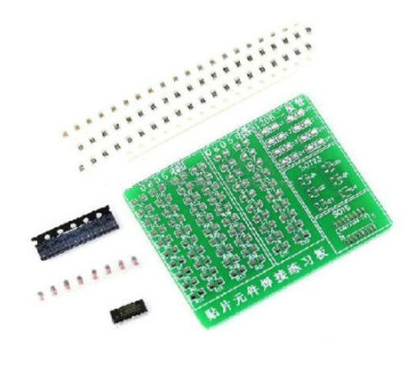The company producing educational sets for high schools and universities of electrical fields and fields focused on industrial automation and digital technology produces sets of electronic components, which also includes a set for mastering basic operations with SMD components. In one production cycle, the company can produce three variants of sets for mounting SMD components. The company is also a distributor and it is distributing the sets from it’s central storage to the individual schools in Prague.

The distances between the central storate and individual schools in kilometers, and the requirements of individual schools in pieces of teaching sets are shown in the following tables.

The company has only two vehicles available, each with a transport capacity of 800 teaching sets. Suggest the best possible shipping plan.

|  |  |  |  |  |  |  |  |  |  |  |
| --- | --- | --- | --- | --- | --- | --- | --- | --- | --- | --- |
| Schood demands: |  | Distances: | | | | | | | | |
|  |  | CS | *S*1 | *S*2 | *S*3 | *S*4 | *S*5 | *S*6 | *S*7 |
|  |  | CS | --- | 3 | 4 | 2 | 6 | 8 | 12 | 5 |
| *S*1: 50 |  | *S*1 | 3 | --- | 3 | 12 | 3 | 2 | 2 | 8 |
| *S*2: 400 |  | *S*2 | 4 | 3 | --- | 2 | 5 | 6 | 3 | 1 |
| *S*3: 250 |  | *S*3 | 2 | 12 | 2 | --- | 5 | 2 | 2 | 3 |
| *S*4: 300 |  | *S*4 | 6 | 3 | 5 | 5 | --- | 1 | 2 | 2 |
| *S*5: 300 |  | *S*5 | 8 | 2 | 6 | 2 | 1 | --- | 5 | 1 |
| *S*6: 100 |  | *S*6 | 12 | 2 | 3 | 2 | 2 | 5 | --- | 3 |
| *S*7: 100 |  | *S*7 | 5 | 8 | 1 | 3 | 2 | 1 | 3 | --- |

**Questions/Tasks:**

1. Divide the schools (places) into two circuits using Mayer's method.
2. For the first circuit, find the most advantageous route using the Vogel approximation method
3. For the second circuit, find the most advantageous route using the nearest neighbor method.
4. **Production of printed circuit boards\***

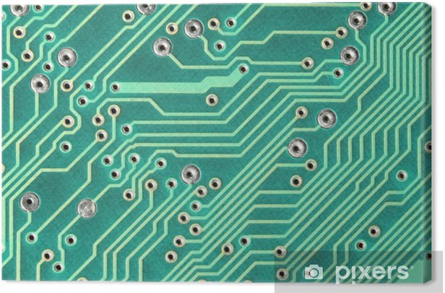The teaching sets also include printed circuit boards (abbreviated PCB). The company manufactures PCB primarily from glass fabric laminate carbonized with epoxy resin. Programmed drilling head drills holes in this board at predetermined positions. Before the actual drilling, the drill head must move above the predefined place and then the actual drilling is performed. The times required for dril head movements and drilling time are listed in the following table.

|  |  |  |  |  |  |  |  |
| --- | --- | --- | --- | --- | --- | --- | --- |
| Manipulační čas vrtné hlavice (s) | | | | | | | |
|  | *O*1 | *O*2 | *O*3 | *O*4 | *O*5 | *O*6 | *O*7 |
| *O*1 | --- | 3 | 10 | 3 | 3 | 3 | 8 |
| *O*2 | 3 | --- | 3 | 6 | 6 | 7 | 1 |
| *O*3 | 10 | 3 | --- | 5 | 2 | 2 | 3 |
| *O*4 | 3 | 6 | 5 | --- | 1 | 2 | 2 |
| *O*5 | 3 | 6 | 2 | 1 | --- | 6 | 2 |
| *O*6 | 3 | 7 | 2 | 2 | 6 | --- | 13 |
| *O*7 | 8 | 1 | 3 | 2 | 2 | 13 | --- |

**Questions/Tasks:**

1. Design the most advantageous path of the drill head using the Vogel approximation method so that the total time required to drill all the holes in the printed circuit board is as short as possible

*printed circuit board is used in electronics for mechanical attachment and at the same time for electrical connection of electronic components. The components are connected by conductive paths, joints created by etching from copper foils glued on an insulating laminate board (glass laminate, clad with copper foil). This creates insulating gaps between the joints. The components themselves are soldered to the PCB behind their terminals with tin solder. Classic designs of components have terminals in the form of wires or pins. These are usually pushed through the holes in the PCB and on the opposite side of the component, they are soldered to the connections made by the copper layer.